**ADVENTUREWORKS SALES DASHBOARD PROJECT REPORT**

Business Request & User Stories

The business request for this data analysis project was an executive sales report for sales managers. Based on the request that was made from the business the following user stories were defined to meet delivery and ensure that acceptance criteria’s were maintained throughout the project.

|  |  |  |  |  |
| --- | --- | --- | --- | --- |
| **#** | **As a (role)** | **I want (goal)** | **So that I (benefit)** | **Acceptance Criteria** |
| **1** | Sales Manager | To get a dashboard overview of internet sales | Can follow better which customers and products sells the best | A Power BI dashboard which updates data once a day with respect to customers and products. |
| **2** | Sales Representative | A detailed overview of Internet Sales per Customers | Can follow up my customers that buys the most and who we can sell more to | A Power BI dashboard which allows me to filter data for each customer |
| **3** | Sales Representative | A detailed overview of Internet Sales per Products | Can follow up my Products that sells the most | A Power BI dashboard which allows me to filter data for each Product |
| **4** | Sales Manager | A dashboard overview of internet sales | Follow sales over time against budget | A Power Bi dashboard with graphs and KPIs comparing against budget. |

Data Cleansing & Transformation (SQL)

To create the necessary data model for doing analysis and fulfilling the business needs defined in the user stories the following tables were extracted using SQL.

One data source (sales budgets) were provided in Excel format and were connected in the data model in a later step of the process.

Below are the SQL statements for cleansing and transforming necessary data.  
  
**DIM_Calendar:**

--Cleansed DimDate Table--

--Required columns used and others not used.--

--Column names changed--

--Shorter month column name created--

SELECT [DateKey]

,[FullDateAlternateKey] AS Date

--,[DayNumberOfWeek]

,[EnglishDayNameOfWeek] AS Day

--,[SpanishDayNameOfWeek]

--,[FrenchDayNameOfWeek]

--,[DayNumberOfMonth]

--,[DayNumberOfYear]

,[WeekNumberOfYear] AS WeekNumber

,[EnglishMonthName] AS Month

, LEFT([EnglishMonthName], 3) AS MonthShort

--,[SpanishMonthName]

--,[FrenchMonthName]

,[MonthNumberOfYear] AS MonthNumber

,[CalendarQuarter] AS Quarter

,[CalendarYear] AS Year

--,[CalendarSemester]

--,[FiscalQuarter]

--,[FiscalYear]

--,[FiscalSemester]

FROM [AdventureWorksDW2022].[dbo].[DimDate]

WHERE [CalendarYear] >= 2021

**DIM_CUSTOMER_JOINED_GEOGRAPHY**:

--- Cleansed customer table---

--Added full name--

--Case statement for Gender--

--Left joined customer and geography tables on column geography key--

--ordered by customer key --

SELECT

CUSTOMER.CustomerKey AS [CustomerKey]

--,[GeographyKey]

--,[CustomerAlternateKey]

--,[Title]

,CUSTOMER.FirstName AS [FirstName]

--,[MiddleName]

,CUSTOMER.LastName AS [LastName]

,CUSTOMER.FirstName + ' ' + CUSTOMER.LastName AS [FullName]

-- ,[NameStyle]

--,[BirthDate]

--,[MaritalStatus]

-- ,[Suffix]

, CASE CUSTOMER.Gender WHEN 'M' THEN 'Male' WHEN 'F' THEN 'Female' END AS [Gender]

--,[EmailAddress]

--,[YearlyIncome]

--,[TotalChildren]

-- ,[NumberChildrenAtHome]

--,[EnglishEducation]

--,[SpanishEducation]

--,[FrenchEducation]

--,[EnglishOccupation]

-- ,[SpanishOccupation]

--,[FrenchOccupation]

--,[HouseOwnerFlag]

--,[NumberCarsOwned]

-- ,[AddressLine1]

--,[AddressLine2]

--,[Phone]

, CUSTOMER.DateFirstPurchase AS [DateFirstPurchase]

-- ,[CommuteDistance]

, GEOGRAPHY.City AS [CustomerCity]

FROM [AdventureWorksDW2022].[dbo].[DimCustomer] AS CUSTOMER

LEFT JOIN [AdventureWorksDW2022].[dbo].[DimGeography] AS GEOGRAPHY ON GEOGRAPHY.GeographyKey = CUSTOMER.GeographyKey

ORDER BY CustomerKey ASC

**DIM_PRODUCT_TABLE:**

--cleansing dimproduct table --

--COLUMN NAMES CHANGED--

--SUBCATEGORY AND CATEGORY TABLES ARE JOINED--

SELECT

PR.[ProductKey]

,PR.[ProductAlternateKey] AS [Product Item Code]

--,[ProductSubcategoryKey]

--,[WeightUnitMeasureCode]

--,[SizeUnitMeasureCode]

,PR.[EnglishProductName] AS [Product Name],

PS.EnglishProductSubcategoryName AS [Product Sub category], --COLUMN FROM SUBCATEGORY TABLE, NULL VALUES IN SUBCATEGORY, DONT KNOW HOW TO GROUP TO WHICH SUB CATEGORY, SO NULL LEFT AS IS, NEED TO GET CLARITY FROM BUSINESS--

ISNULL(PC.EnglishProductCategoryName, 'Components' ) AS [Product Category] --COLUMN FROM CATEGORY TABLE, NULL VALUES IN PRODUCT CATEGORY CHANGED TO COMPONENTS--

--,[SpanishProductName]

--,[FrenchProductName]

--,[StandardCost]

--,[FinishedGoodsFlag]

,PR.[Color] AS [Product Colour]

--,[SafetyStockLevel]

--,[ReorderPoint]

--,[ListPrice]

,PR.[Size] AS [Product Size]

--,[SizeRange]

--,[Weight]

--,[DaysToManufacture]

,PR.[ProductLine] AS [Product Line]

--,[DealerPrice]

--,[Class]

--,[Style]

,PR.[ModelName] AS [Product Model name]

--,[LargePhoto]

,PR.[EnglishDescription] AS [Product Decription]

--,[FrenchDescription]

--,[ChineseDescription]

--,[ArabicDescription]

--,[HebrewDescription]

--,[ThaiDescription]

--,[GermanDescription]

--,[JapaneseDescription]

--,[TurkishDescription]

--,[StartDate]

--,[EndDate]

,ISNULL(PR.STATUS,'Unknown') AS [Product Status] --NULL ENTRIES ARE CHANGED TO UNKNOWN--

FROM [AdventureWorksDW2022].[dbo].[DimProduct] AS PR

LEFT JOIN [dbo].[DimProductSubcategory] AS PS ON PS.ProductSubcategoryKey = PR.ProductSubcategoryKey

LEFT JOIN [dbo].[DimProductCategory] AS PC ON PC.ProductCategoryKey = PS.ProductCategoryKey

ORDER BY PR.ProductKey ASC

**FACT_INT_SALES_TABLE:**

--CLEANSING INTERNET SALES TABLE--

SELECT

[ProductKey]

,[OrderDateKey]

,[DueDateKey]

,[ShipDateKey]

,[CustomerKey]

--,[PromotionKey]

--,[CurrencyKey]

--,[SalesTerritoryKey]

,[SalesOrderNumber]

--,[SalesOrderLineNumber]

--,[RevisionNumber]

--,[OrderQuantity]

--,[UnitPrice]

--,[ExtendedAmount]

--,[UnitPriceDiscountPct]

--,[DiscountAmount]

--,[ProductStandardCost]

--,[TotalProductCost]

,[SalesAmount]

--,[TaxAmt]

--,[Freight]

--,[CarrierTrackingNumber]

--,[CustomerPONumber]

--,[OrderDate]

--,[DueDate]

--,[ShipDate]

FROM [AdventureWorksDW2022].[dbo].[FactInternetSales]

WHERE LEFT(OrderDateKey, 4) >= YEAR(GETDATE()) - 2 --TAKING TWO YEARS PRIOR--

ORDER BY OrderDateKey ASC

Data Model

Below is a screenshot of the data model after cleansed and prepared tables were read into Power BI.

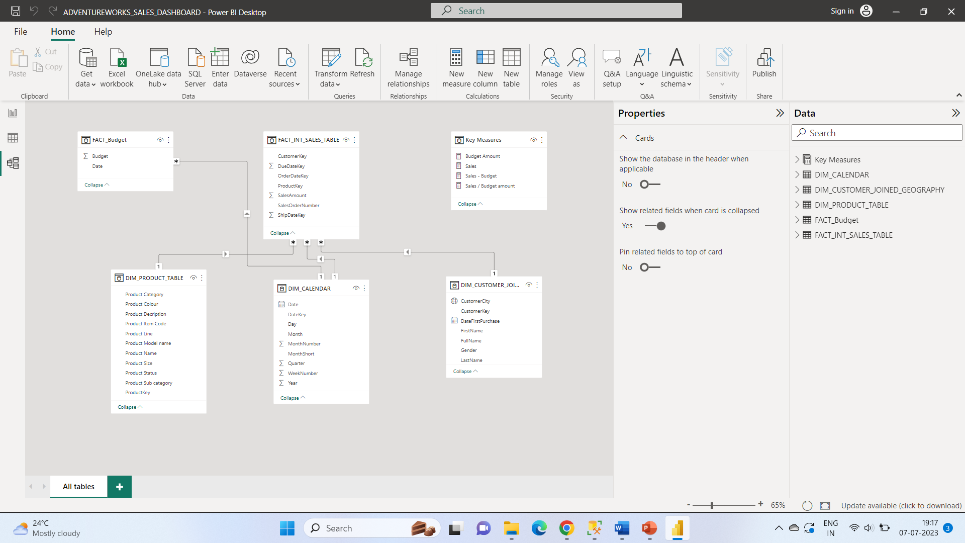

Sales Management Dashboard

The finished sales management dashboard with one page which works as a dashboard and overview, with two other pages focused on combining tables for necessary details and visualizations to show sales over time, per customers and per products.

**All the files are in github.**

